1. **Peering connection**

* A vpc peering connection is a networking connection between two vpc that enable you to route traffic between them using private ipv4 address and ipv6 address.
* Instances in either vpc can communicate with each other as if they are within in the same network.
* You can create a vpc peering connection between your own vpc or with a vpc in another asw account.
* The vpc can be in different region.

**1.1 First of all create two different vpc.**

Login aws account **>** service **>** ec2 **>** network **>** vpc

There is 4 step required to create a vpc

1. Create vpc
2. Sunet
3. Integrate way
4. Route table

**1.2 Create vpc**

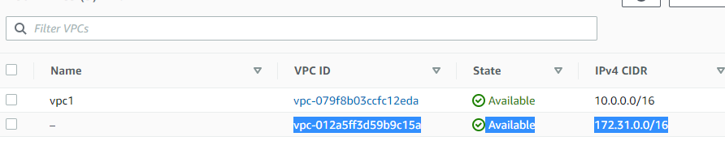

**1.3 subnet**

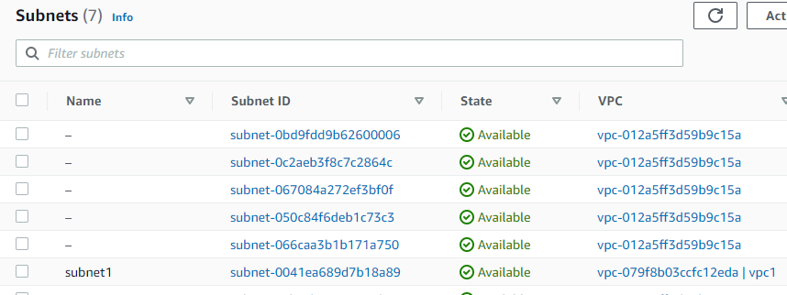

**1.4 internet gateway**

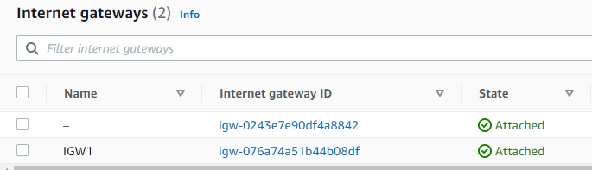

**1.5 Route table**

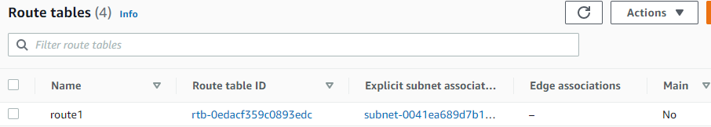

**2. Another vpc create**

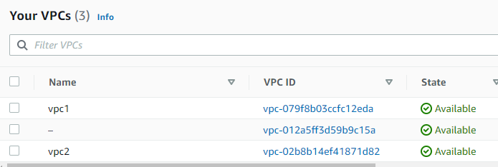

**2.1 Subnet2**

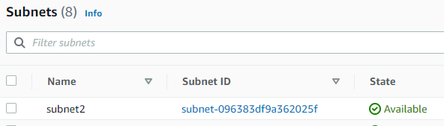

**2.2 internet gateway (igw2)**

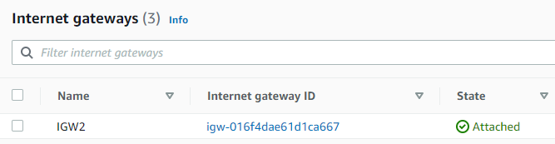

**2.3 Route table (route2)**

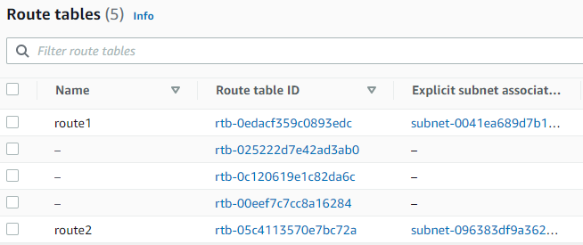

This is perfectly done now we can create instance with the help of own created vpc.

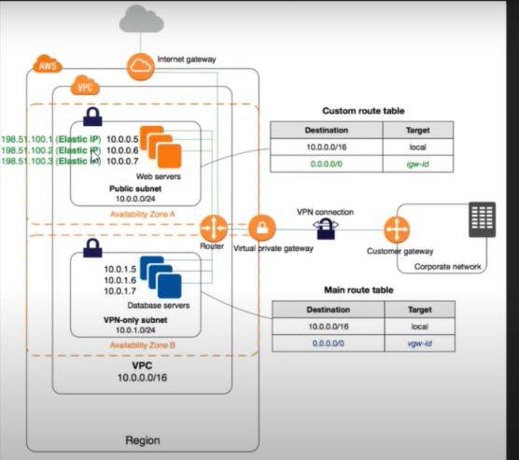

I am created two vpc in a region but at different availability zone.

**3. Create peering connection between vpc1 to vpc2.**

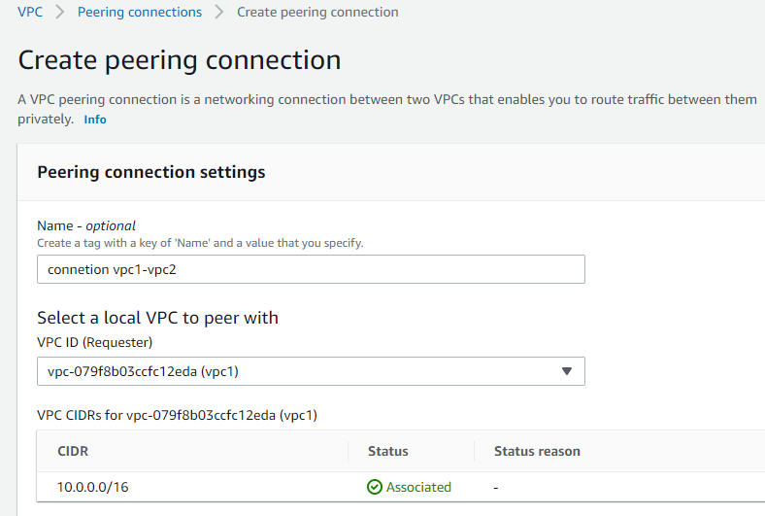

We are doing the configuration of peering connection as connection vpc1 - vpc2

And choose the vpc 1 as requested which is going to give request and acceptance vpc2.here we can create in my account and another account too so a to can able to communicate one instance to another instance at different region but i am created i my account as assignment.

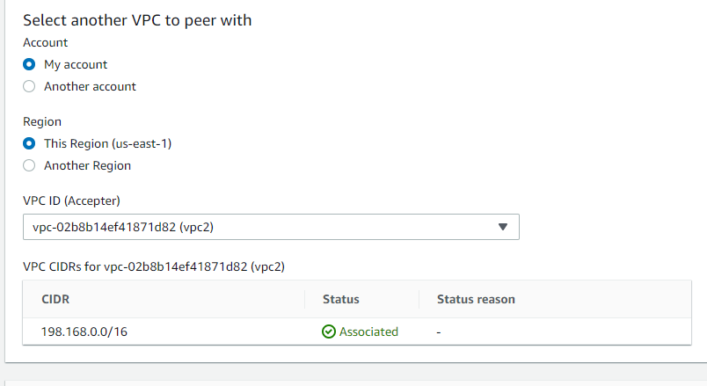

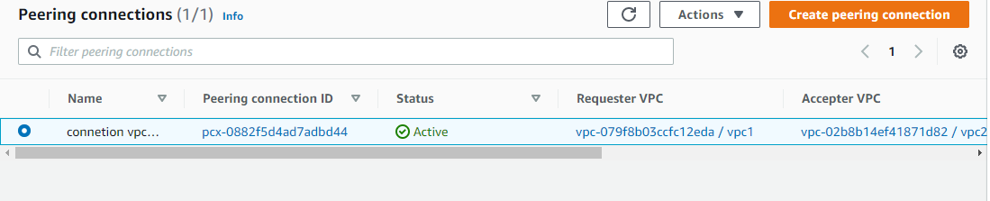

Perfect ! here successfully done creation of peering connection. Now we have to give direction to communicate each other.

**4. Destination of communicate the instances to each other.**

* 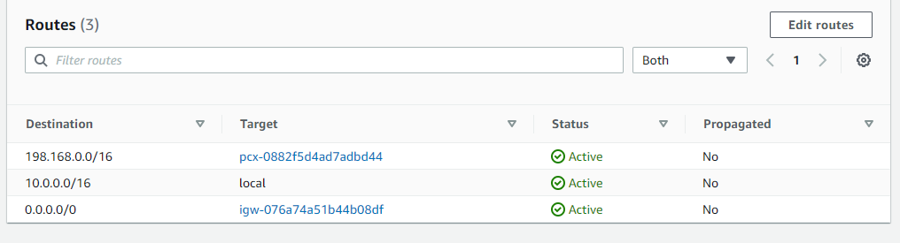

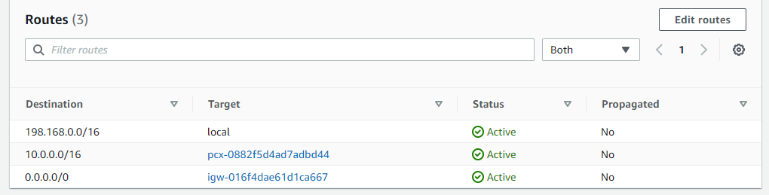

* In route 1 i give destination CRDI is 198.168.00/16 which is connected with peering connection as we see
* In route table 2 i give direction CRDI is 10.0.0.0/16 which connected with with peering connection too. So as to they are communicate to each other.
* Now i am going to launch the two different instance at two different availability zone but in a same region.

**5 To launch the two instances**

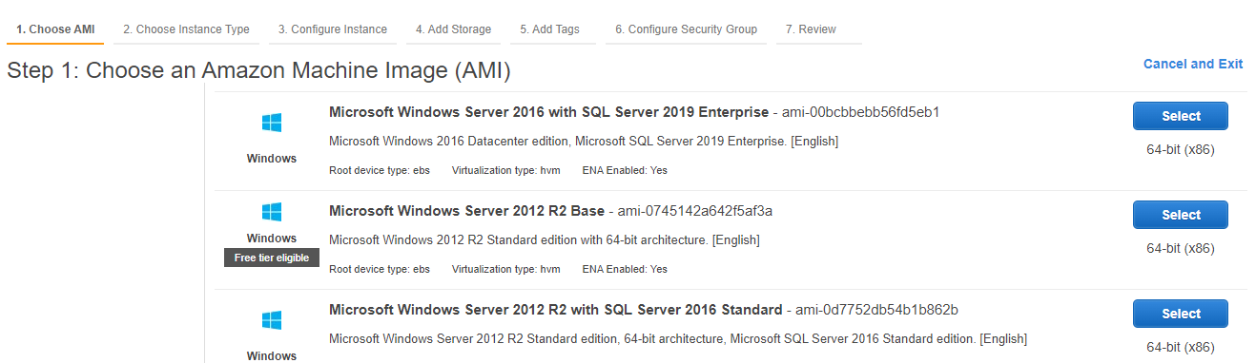

1

2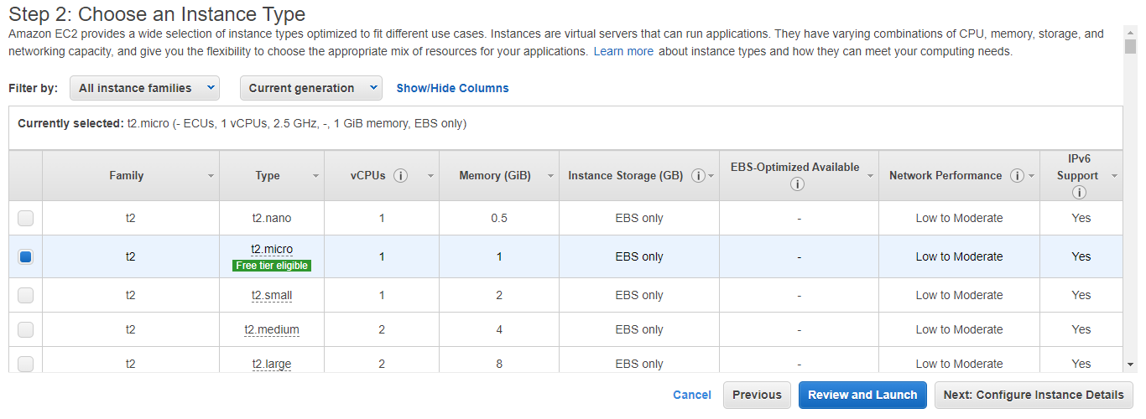

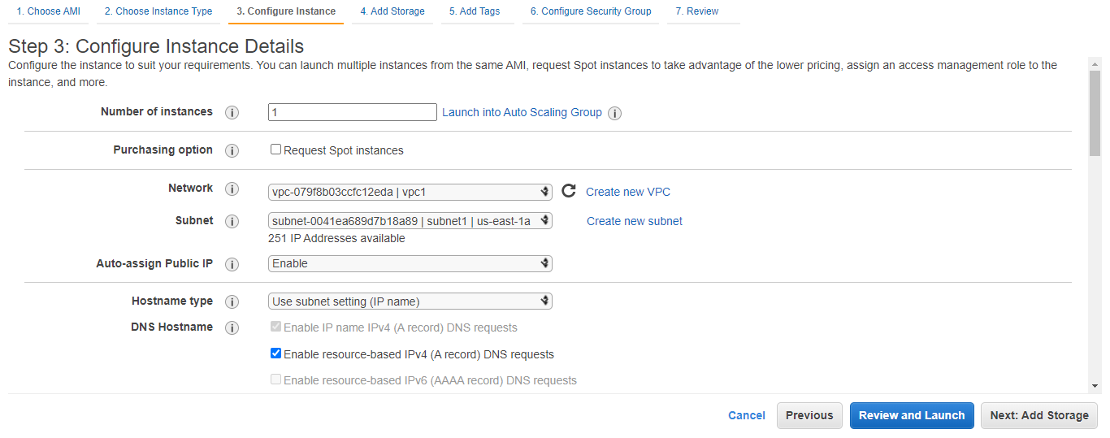

3

4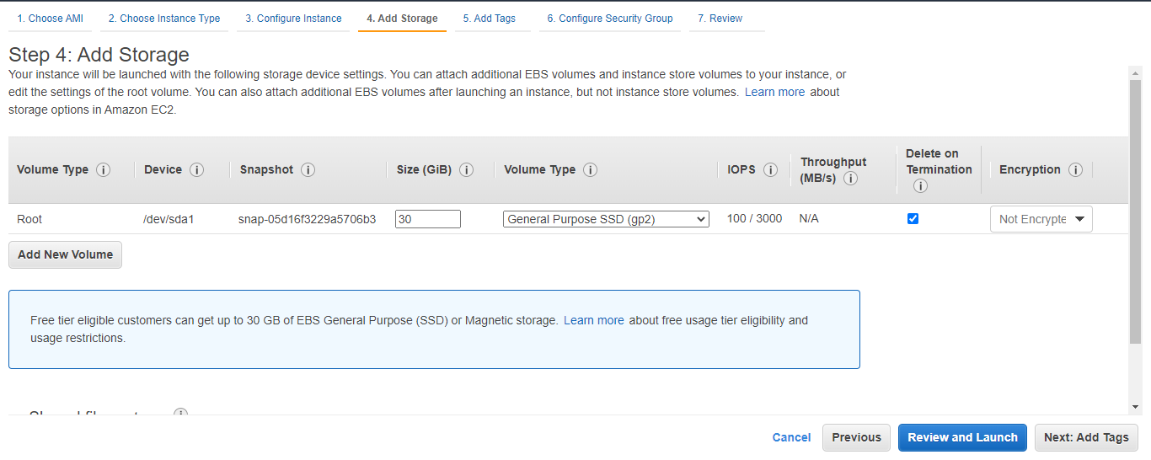

5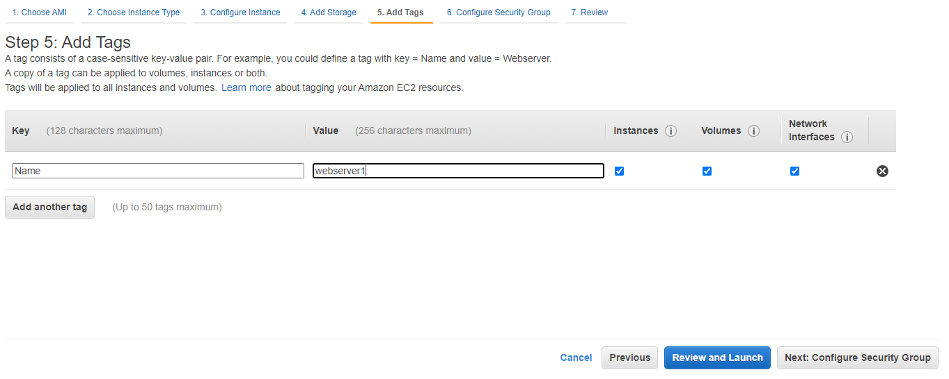

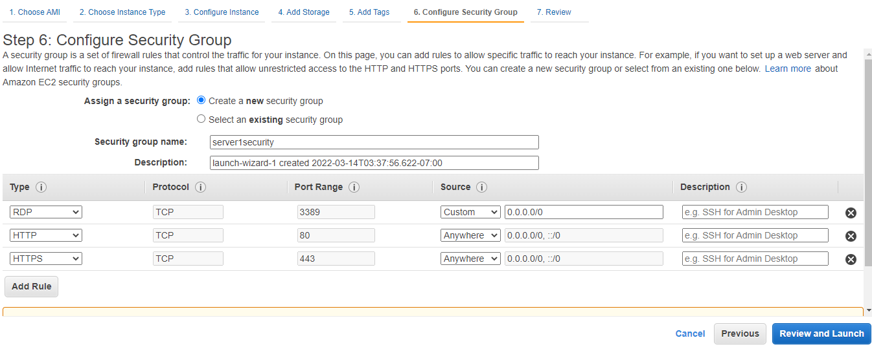

6

7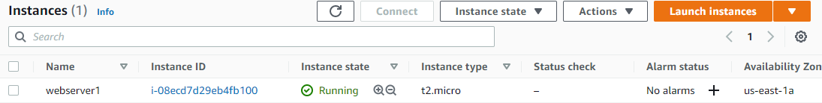

First instance successfully done with help of vpc1.

**6 creation of one more instance with the help of vpc2.**

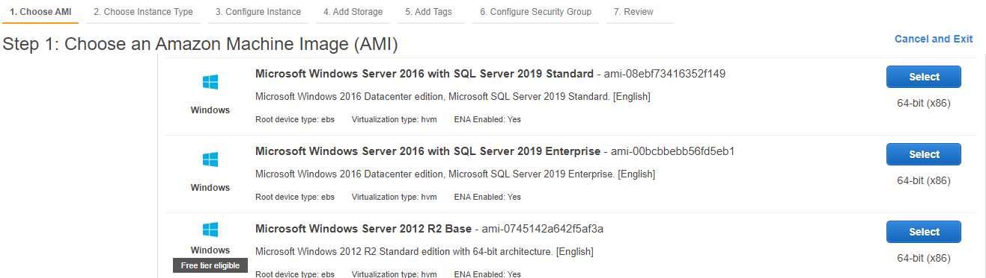

I am selected windows server 2012 R2 base.

**2**.

3. 

4.

5.



6.

7.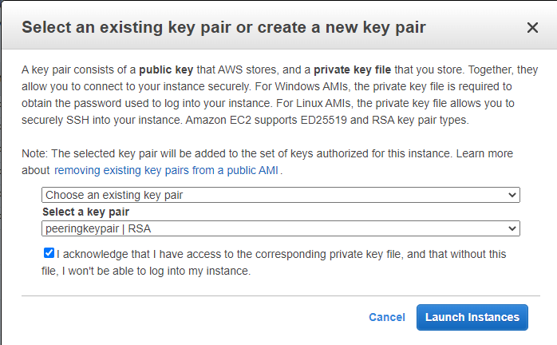

Now it is successfully done and we go for take rdp to connection with the server1 and server2.

* Select **>** webserver1 **>** action **>** RDP **>** download RDP **>** get password **>** decrypt password **>** open RDP file **>** connect.
* After connect to the server open cmd and ping to the another instance with his private IP it reply .

Webserver1

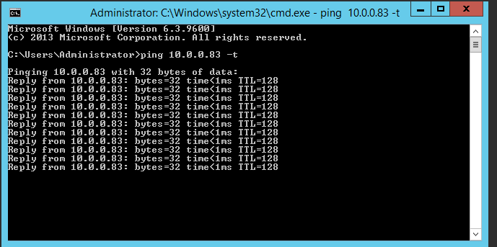

Webserver2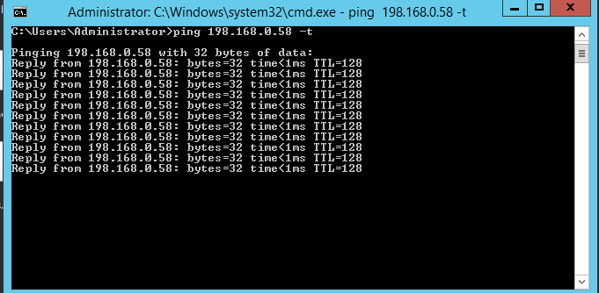

Webserver1 and webserver2

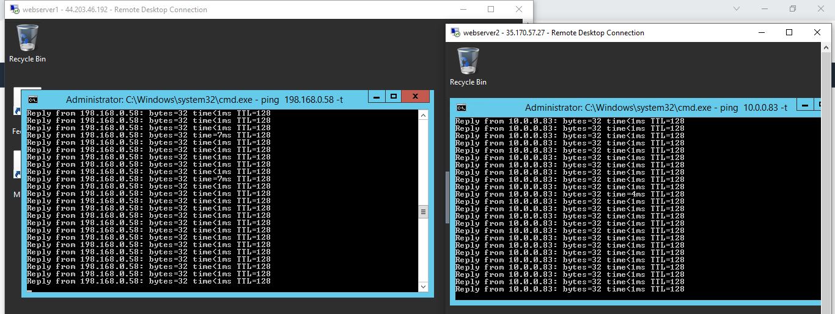

Perfect both instances are pinging to each other it means they can communicate.